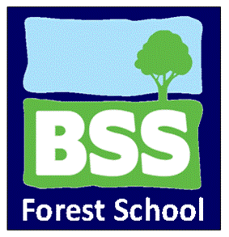

Forest School Kit List

The following list is intended as guide to ensure you are suitably equipped for a day in the woods. We want everyone to have fun and enjoy the day, and being kitted out correctly can help you do just that. It’s up to you to judge the weather on the day in terms of choosing what to wear, but remember the good old British climate means things can change quite quickly. We believe there is no such thing as bad weather, just bad clothes and we will be going out, regardless of weather conditions (except gale force winds), so come as prepared as possible to make sure you get the most out of the day! Lots of layers always help, because you can always remove a few if you get too hot and clothes you don’t mind getting a bit muddy are always good too!

- Waterproof coat
- Waterproof over trousers
- Sturdy boots or wellies (Wellies can make your feet very cold, so wear big, warm socks if possible)
- Spare socks
- A plastic bag for muddy gear
- Lots of layers (you can always take one off if too hot)
- Clothes you do not mind getting dirty (e.g. old tracksuit bottoms. Jeans, although great for protecting you from brambles can also make you very cold, so if you are wearing an old pair of jeans, stick some tights or leggings on underneath if it is a chilly day.
- Hat, gloves, scarf (if cold)
- Sun hat, sun cream (if hot)

